Units 5–6 QUIZ
Name: _______fernanda __________________
Date: _________________________
Score: _________________________
Listen to the conversations. Complete the sentences. (4 POINTS)
A
►
1. On Saturdays, Judy _____get up________ at 4:30 in the morning.
2. Rich live downtown with his brother.
3. On Sundays, Tracey ___lunch_________ with her family.
4. On Mondays, Wednesdays, and Fridays, Greg _____ class________ downtown.
Complete the sentences. (3 POINTS)
B


1. It’s twenty_to__ twelve. 2. It’s __twenty -five to_ five. 3. It’s six _fifty-five .
Read the article. Then check () two correct answers for each sentence. (3 POINTS)
C

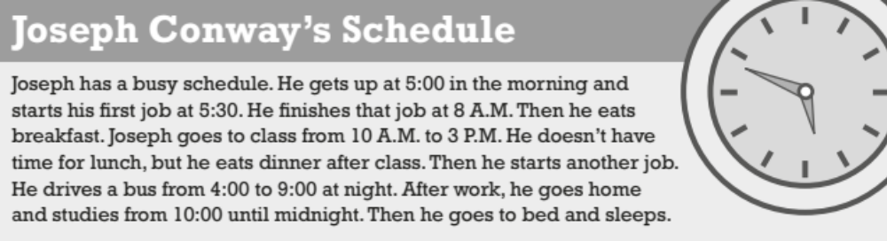
1. Joseph _____ . | 3. Joseph eats _____ .
 is a student |  breakfast
 has one job |  dinner
 takes the bus |  lunch
 studies at night |  late at night
2. Joseph works from _____ .
 5:30 a.m. to 8:00 a.m.
 10:00 a.m. to 3:00 p.m.
 4:00 p.m. to 9:00 p.m.
 10:00 p.m. to midnight
Complete the conversations with present continuous Wh-questions. Use the words in parentheses. (3 POINTS)
D
Example: A: __________________________________________________
What’s Kyle doing?
(Kyle / do)
B: He’s reading a book.
1. A: ____what Brenda and katie_ are studying_____________________________________________________ ?
(Brenda and Katie / study)
B: Math and science.
2. A: where julio working___________________________ ?
(Julio / work)
B: In an office.
3. A: _where are you going_________________________________________________________ ?
(you / go)
B: To the supermarket.
Match the verbs with the nouns. Use each verb once. (6 POINTS)
E
b
1. have _____ | a. a bike
2. eat __d___ | b. breakfast
3. play ___f__ | c. a walk
4. ride ___a__ | d. dinner
5. listen to _g___ | e. a movie
6. take _c___ | f. tennis
7. watch __e___ | g. music
Each conversation has three underlined words or phrases. One is not correct. Circle the incorrect word or phrase.
F

(6 POINTS)
Example: A: Does you live downtown?
B: No, I live in the suburbs.
1. A: Do your brother work in the morning?
B: No, he works at night.
2. A: When does Carol have lunch?5re
B: She have lunch at noon.
3. A: Does your father goes to work by bus?
B: No, he takes the train.
4. A: What are you make?
B: I’m making spaghetti for our dinner.
5. A: What’s your father doing right now?
B: He sleeping.
6. A: Are your friends study today?
B: Yes, they are.

